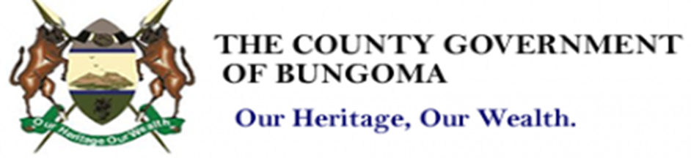
Department of Gender, Culture, Youth and Sports
Public Notice: Call for Comments/Inputs on the Proposed Draft of The Bungoma County Youth, Women and PWDs Empowerment Fund Regulation, 2025.
The County Government of Bungoma (CGB) through the Department of Gender, Culture, Youth and Sports, has reviewed and develop a merged version of The Bungoma County Youth, Women and PWDs Empowerment Fund Regulation,2025 that aims to regulate the overall single operational framework and management of the empowerment Fund for the vulnerable groups in Bungoma County.
The department is tasked to merge the regulations into a single empowerment entity following the Controller of Budget, Office of the Auditor –General, the Senate and the County Assembly of Bungoma recommendation. The task involves undertaking a comprehensive review of the draft regulations in line with the PFM Act-2012 and other laws thereof and to conduct a stakeholders and public consultation in accordance with the Constitution. The department therefore invites relevant Stakeholders, Members of the Public and all interested parties to provide suggestion(s), view(s) and input(s) with justifications on the draft regulations which shall inform changes thereof. The copies of the draft regulations and the template to guide the submissions of public comments are available at Sub-county & Ward Administration offices and the following link: www.bungoma.go.ke. Written submissions should be submitted to Sub-county & Ward Administration offices, and the department not later than 4th July 2025, through gender@bungoma.go.ke or the address of the signatory as stated below.

The County Executive Committee Member,
Department of Gender, Culture, Youth and Sports. County Government of Bungoma
P.O Box 437-50200

