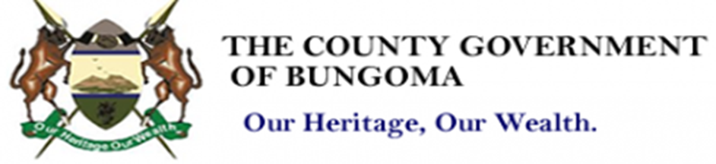
DEPARTMENT OF GENDER, CULTURE, YOUTH AND SPORS.
Template to Guide Submission of Comments/memoranda on the proposed Bungoma County Youth, Women and PWDs Empowerment Fund Regulation, 2025
THE BUNGOMA COUNTY YOUTH, WOMEN AND PWDs EMPOWERMENT FUND REGULATIONS,2025
Name of Organization/Individual:
CONTACT
S/No. | Section of Regulations Affected | Proposal | Justification

