COUNTY GOVERNMENT OF BUNGOMA
MONITORING AND EVALUATION DIRECTORATE

Free Farm Input Program Evaluation Report
(Maize Seed and Fertilizer Issued to Vulnerable Farmer Households in 2018)

Julia Makokha – Maraka Ward Antony Wanjala – Namwela Ward
Mary Wafula – Matulo Ward Christine Masinde – Maraka Ward

September, 2018

EXECUTIVE SUMMARY
The Monitoring and Evaluation Department undertook an evaluation exercise to determine the relevance, effectiveness, efficiency, impacts and sustainability of the free farm input (certified maize seed and fertilizer) issuance program implemented by the County Department of Agriculture, Livestock, Fisheries, Irrigation and Cooperatives.
Whereas the program has been ongoing since FY 2013/14, this exercise focused on the FY 2017/2018 input beneficiaries. Out of the 32,610 beneficiaries, 178 beneficiaries were sampled and interviewed by the evaluation team using the checklist provided. 69.7% of the beneficiaries were female while 30.3% were male. 4% were people living with disability while 10.2 % of the sampled populations were youth. About 70% of the beneficiaries sampled had primary education as their highest level of education. 43.3 % of the beneficiaries are widowed majority of whom are female. Average household size was 7; average size of land owned was 2.3 acres and average size of land under maize production was 1.1 acres.

ACKNOWLEDGEMENT

May God bless you

Emukule J.I
DIRECTOR MONITORING AND EVALUATION.

TABLE OF CONTENTS

LIST OF TABLES

INTRODUCTION

1.1 Background

The population of Bungoma County is estimated at 1,809,309 of which the female population constitutes 51.2% while male are 48.8%. It has a population density of 529 people per km2 and a growth rate of 3.1% p.a.

Out of the 3,032.4km2 of surface, a total of 2880.78 km2 accounting for 95% of all land is arable. Consequently, Bungoma is predominantly an agricultural County with potential of producing enough food for both domestic use and trade. Food and cash crops constitute the major economic activities. Agriculture contributes 60% of household incomes in Bungoma County and rural self-employment stands at 4.8%. The average land holding in the County is 0.4-2ha for small scale farmers which account for over 90% of land holding and over 75% of the total agricultural output and 70% of the total marketed output respectively. Medium and large scale institutional farms range from 3ha- 50ha.

Despite this huge potential, the County’s absolute poverty index for urban and rural areas stands at 47.6% and 53% respectively while food poverty stands at 42% (HH survey, 2014). Key Strategic issues affecting the Agriculture sector in Bungoma include; low productivity and production, inadequate extension officers, low adoption of agricultural technologies, high cost of farm inputs, poor market access, low value addition amongst others.

The County Government of Bungoma through the Department of Agriculture, Livestock, Fisheries, Irrigation and Cooperatives has established programmes, projects, initiatives and activities to address the strategic issues. The department through the crops development and management programme undertook the farm input support initiative of issuing free certified maize seed and fertilizer to vulnerable farmers in the 45 Wards. The main objective of the program was to enhance maize productivity, outputs, and livelihoods amongst beneficiaries.

The program has been implemented since the Financial Year (FY) 2013/14. 96,750 farmers benefited from FY 2013/14 to FY 2016/17 while 50,246 benefited from FY 2017/18 to FY 2018/19. Considering the cost of this initiative, there was need for program evaluation to inform future decisions regarding the program. The evaluation exercise targeted FY 2017/18 beneficiaries where a total of Khs. 238,053,000 was spent to benefit 32,610 farmers with certified maize seed and fertilizer.

1.2 Objectives of the Program Evaluation
- To collect and collate background information including household characteristics, production and consumption characteristics and program sustainability features.
- To determine the relevance and level of achievement of program objectives, effectiveness, efficiency, impacts and sustainability of the program.
- To give recommendations based on key observations noted in the evaluation process.

2. Methodology

2.1 Selection of the sample beneficiaries

Out of the 32,610 input beneficiaries in FY 2017/18, 178 were selected as a sample for purposes of this study as highlighted in the table below:

Table 1: Farmers sampled
Sub county | Wards | Frequency per ward | Frequency per sub county | Percent
Bumula | West Bukusu | 9 | 20 | 11.2
 | Kimaeti | 11
Kabuchai | Chwele/Kabuchai | 10 | 21 | 11.8
 | West Nalondo | 11
Kanduyi | Khalaba | 10 | 20 | 11.2
 | Musikoma | 10
Kimilili | Kimilili | 10 | 21 | 11.8
 | Maeni | 11
Mt Elgon | Elgon | 10 | 12 | 6.7
 | Kaptama | 2
Sirisia | Malakisi/Kulisiru | 10 | 23 | 12.9
 | Namwela | 13
Tongaren | Mbakalo | 11 | 22 | 12.4
 | Milima | 11
Webuye East | Maraka | 12 | 20 | 11.2
 | Mihuu | 8
Webuye west | Bokoli | 9 | 19 | 10.7
 | Matulo | 10
Total | 18 | 178 | 178 | 100.0

  - Data Collection Process

The data collection process used a semi-structured checklist for interview of input beneficiaries. Data collection was also done by taking photos of the respective beneficiaries. Data collected was both quantitative and qualitative in nature.
  - Data Analysis Process
Data collected was analysed by use of Microsoft Excel.

3.0 FINDINGS
3.1 Household characteristics

3.1.1 Beneficiary distribution by Gender

Table 2: Beneficiary distribution by Gender
 |  | Number | Percentage
Gender | Female | 124 | 69.7
 | Male | 54 | 30.3
Total |  | 178 | 100

Out of the 178 beneficiaries, 7 (male 4, female 3) were people living with disability

3.1.2 Beneficiary distribution by Age groups

Table 3: Beneficiary distribution by Age groups
 |  | Gender |  | Total | Percentage
 |  | Female | Male
AGE GROUP | Below 20 | 1 | 0 | 1 | .6
 | 21 to 35 | 15 | 2 | 17 | 9.6
 | 36 to 50 | 29 | 14 | 43 | 24.2
 | 51 to 65 | 46 | 22 | 68 | 38.2
 | above 65 | 33 | 16 | 49 | 27.5
Total |  | 124 | 54 | 178 | 100

10.2 % of the sampled population were youth.

3.1.3 Beneficiary distribution by Education level

Table 4: Beneficiary distribution by Education level
 |  | Gender |  | Total
 |  | Female | Male
Education Level | Non formal | 32 | 8 | 40 (22.5%)
 | Primary | 61 | 23 | 84(47.2%)
 | Secondary | 24 | 21 | 45(25.3%)
 | Middle Level College | 6 | 2 | 8(4.5%)
 | University | 1 | 0 | 1(0.6%)
Total |  | 124 | 54 | 178(100%)

About 70% of the beneficiaries sampled had primary education as their highest level of education.

3.1.4 Beneficiary distribution by marital status

Table 5: Beneficiary distribution by marital status
 |  | Gender |  | Total
 |  | Female | Male
Marital Status | Married | 47 | 47 | 94(52.8%)
 | Separated | 4 | 0 | 4(2.2%)
 | Single | 3 | 0 | 3(1.7%)
 | Widowed | 70 | 7 | 77(43.3%)
Total |  | 124 | 54 | 178(100%)

43.3 % of the beneficiaries are widowed majority of whom are female.

3.1.5 Household size and land Use

Table 6: Household size and land Use
Variable | Average
Household Size | 7
Size of land owned (Acres) | 2.3
Size of Land under Maize production (Acres) | 1.1

3.2 Production and consumption characteristics and details
Table 7: Production and Consumption Characteristics
Variable | Average
Quantity of maize given in 2018 (Kgs) per beneficiary | 9.3
Quantity of fertiliser given in 2018 (Kgs) per beneficiary | 96.44
Acres of land to which inputs were put | 0.94
Yield realized ( No. of 90 Kgs bags) per acre | 11.1
No. of 90kg bags sold | 7.1
No. of 90kg bags Consumed | 6.2
Consumption Duration in months | 9
Cash from other farm products sold | 20530.2
Acres of maize planted in 2019 | 0.9

3.3 Source of Funds of the non-beneficiaries of free farm input of 2018/19 FY

Table 8: Source of Funds of the non-beneficiaries of free farm input of 2018/19 FY
Source of Funds | Number
No response | 2
Self-Sponsored | 136
One Acre Fund | 4
Relatives | 2
Total | 144

3.4 Key Evaluation Aspects findings
Table 9: Key Evaluation Aspects Findings
Aspect | Description | Project observations | Conclusion
Relevance | Extend to which the objectives of an intervention are consistent with the beneficiaries needs, requirements, county needs | 45% of the beneficiaries were mainly widowed and a few singles with an average daily expenditure of $0.57 (Kshs. 57) which is less than a dollar per day | The vulnerable were captured therefore the program was relevant
Effectiveness | Extend to which the development intervention’s objectives were achieved. (Did productivity increase?) | The county average yield per acre is 13.8 (90 kgs bags).  The average yield of the vulnerable households before intervention was 8 (90kgs) bags. The average yield obtained by the vulnerable households after intervention was 11 bags (90 kgs bags). This slightly falls short of the county average yield per acre but shows intervention’s objectives were achieved. | The yields increased from 8 bags to 11 bags translating to an increase of 37.5% hence the program was effective.
Efficiency | A measure of how economically resources/inputs are converted to results (cost of producing a unit bag of maize) | The average yields obtained were 11 bags (90kgs) per acre. This compared to the cost of production of maize in 1 acre gives the cost of production of one bag of maize as Kshs. 2,248 compared to average selling price of Kshs. 2,500 per bag. | The cost of production of 1 bag was Kshs. 2,248 which is close to the selling price of 1 bag (Kshs. 2,500) hence not efficient.
Impact | The positives and negatives, long term effects produced by a development intervention, directly or indirectly, intended or unintended. | Before the free farm input program, the beneficiaries average maize produce of 8 bags lasted for an average of 6 months. After the implementation of the program, the average maize produce of 11 bags lasted for an average of 9 months.  The income generated was invested in various activities including paying school fees for their children, financing season 2 farm production, paying medical bills among others. | The increased maize productivity is sustaining households for a longer period of 9 months which is closer to 12 months when the next harvest is done. Beneficiaries are hence moving towards food security.
Joan Naswa – Mbakalo Ward who bought a cow out of the maize sales  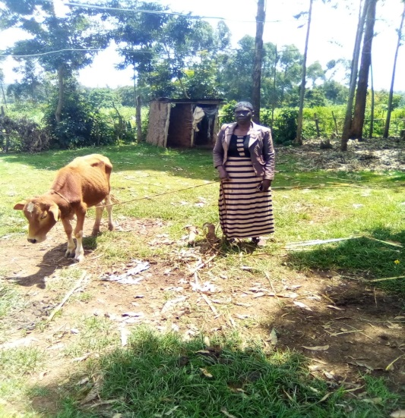 |  | Irene Namalwa – Milima Ward who bought iron sheets for the son’s house out of the maize sales  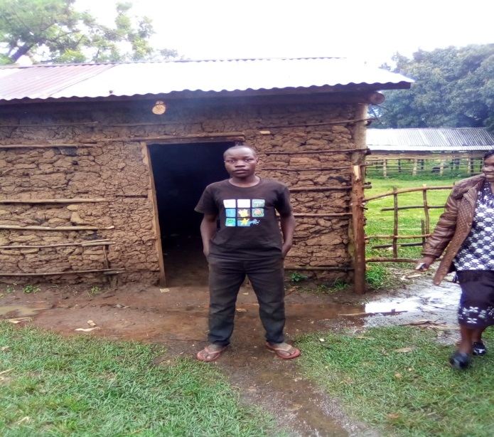
Sustainability | The continuation of benefits from a development intervention after major development assistance has been completed. The resilience to risk of the net benefit flows over time.(evidence of sustaining the yields) | It was noted that 30 households still received free farm inputs in the subsequent year 2019. Out of the 144 who did not receive free farm inputs in 2019, only 1 bought from sale of the 2018 maize yield while 134 beneficiaries were able to buy farm inputs from other sources of income other than maize sales. | 75.3% of the beneficiaries were able to buy their own inputs for maize production in the subsequent year while approximately 17% still depended on the County Government for inputs in the subsequent year.

4. Conclusion and Recommendations
4.1 Key Findings
From the findings it can be deduced that;
- Maize productivity increased by an average of 37.5% (From 8 to 11 bags)
- Household maize stock period increased averagely from 6 to 9 months there by enhancing the food security status of the beneficiaries.
- On average, 7.1 bags were sold (translating to approximately Kshs. 17,750). This enabled the beneficiary households to meet other household needs.
- Average daily income of the beneficiaries was Khs. 57 indicating their vulnerability and hence relevance of the program

4.2 Recommendations
For optimal and sustained benefits the line department should consider the following:

